**Tracing Stage- Harpreet singh**

**Bug: 1**

**Booking .java**

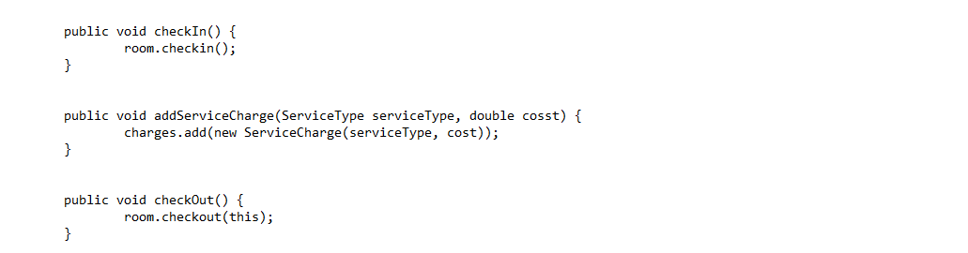

BUG 1

The above picture the given bug in the file Booking.java. However, it can be clearly seen that are double ‘S’ instead of one which doesn’t let the system to show the outstanding amount of the services used by the guest and displays the amount $0.00 while checkout. The bugs are can be fixing the minor errors in add Service Charges.

**Bug: 2**



Bug 2.1

Bug 2.2

The above red arrow shows the second bugs in the file Booking.java. Moreover, these errors indicate, the missing statement which control the state of guest check-in and checkout.

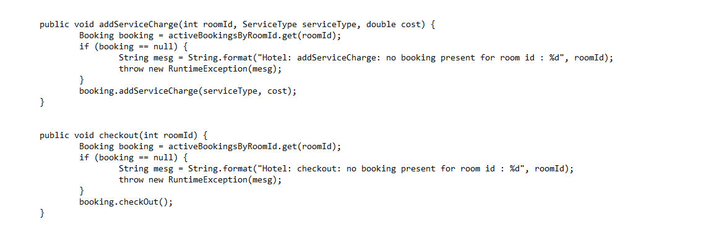

Bug 2.3

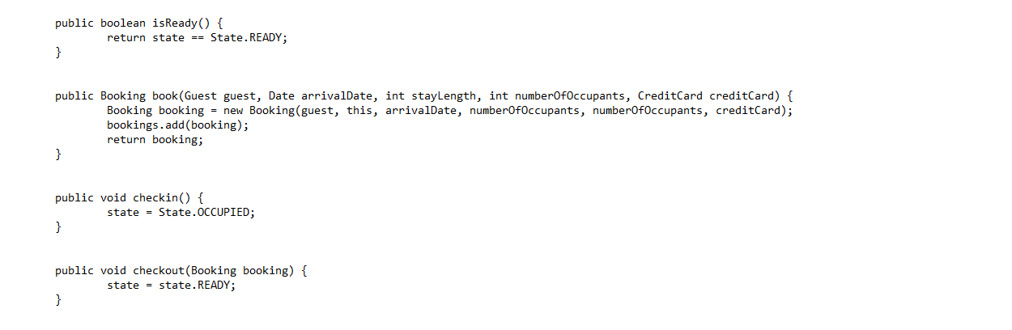

Bug 2.4

The above picture indicates the statement missing in the given entity Hotel.java. Due to this, the user is unable to change the status of the guest booking at the time checkout. To change the status or to remove from the system to prevent extra charges to the guest based on the room number I had added a new statement at the end of the given code.